

## VRNE

1328 S Indian Ave.

Tulsa, OK 7127

(405) 694-8080

**VRNE Week Two**

Thanks for the great feedback!

**Week Two Update**

Accomplishments 1

ToDos 1

Review 1

# Week Two Update

## Accomplishments

* Collected 55k photos of 2300+ parcels
* Add multiple photos per parcel per road.
* Annotated 1000+ Norman Photos
* Add Wide Angle Camera Lens

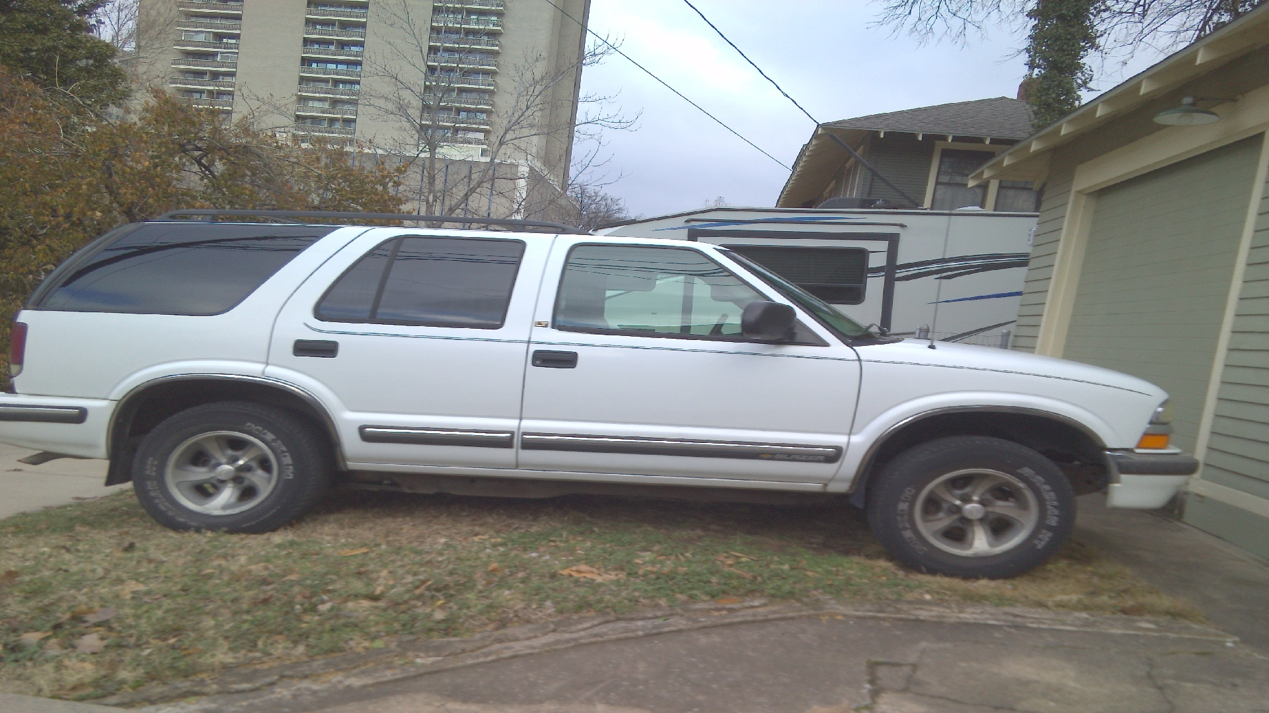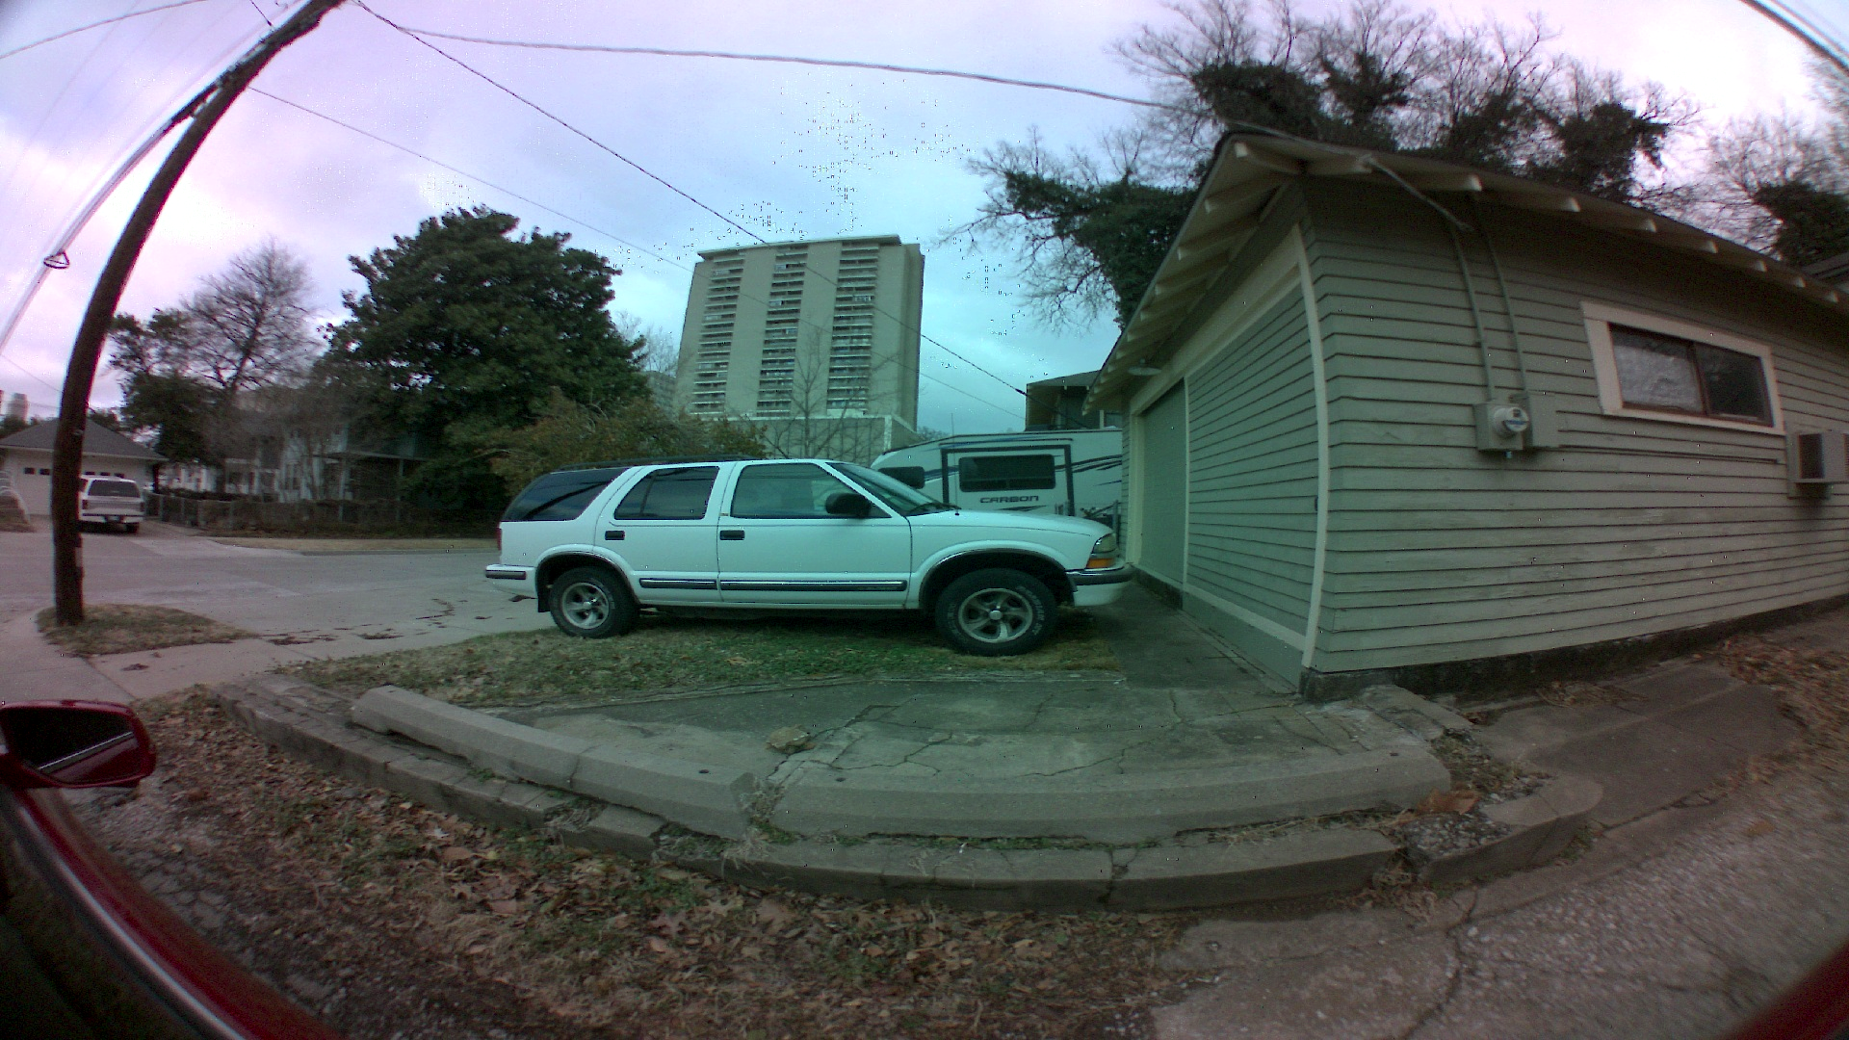

* 10+ Tasks reviewed

## ToDos

* Discuss timing and priority of task reviews.
* Retrain Model with Norman Images
* Add Date Time to Photos
* Add Auto Navigate to In Progress
* Add Better Zoom to APP
* Fix Lens Flare

## Review

* Review some of the tasks to clarify responses.